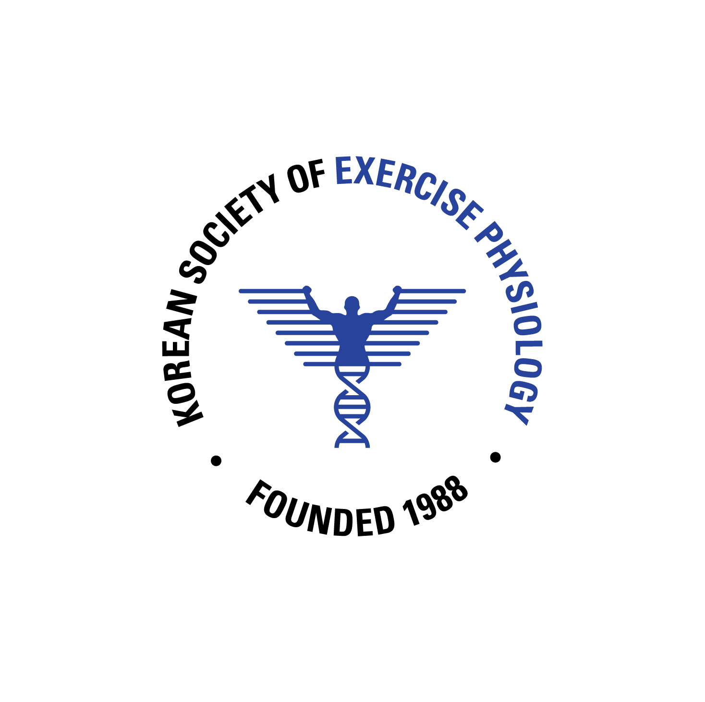 | 2022 International Conference of the KSEP  Oral Presentation Abstract and Video Guidelines
Submission Deadline

The deadline for abstract and presentation file (ppt) submission is March 11, 2022.
The deadline for the oral presentation video (mp4) is March 11, 2022.
The Curriculum Vitae (CV) submission deadline is March 11, 2022.

Gil-Dong Hong
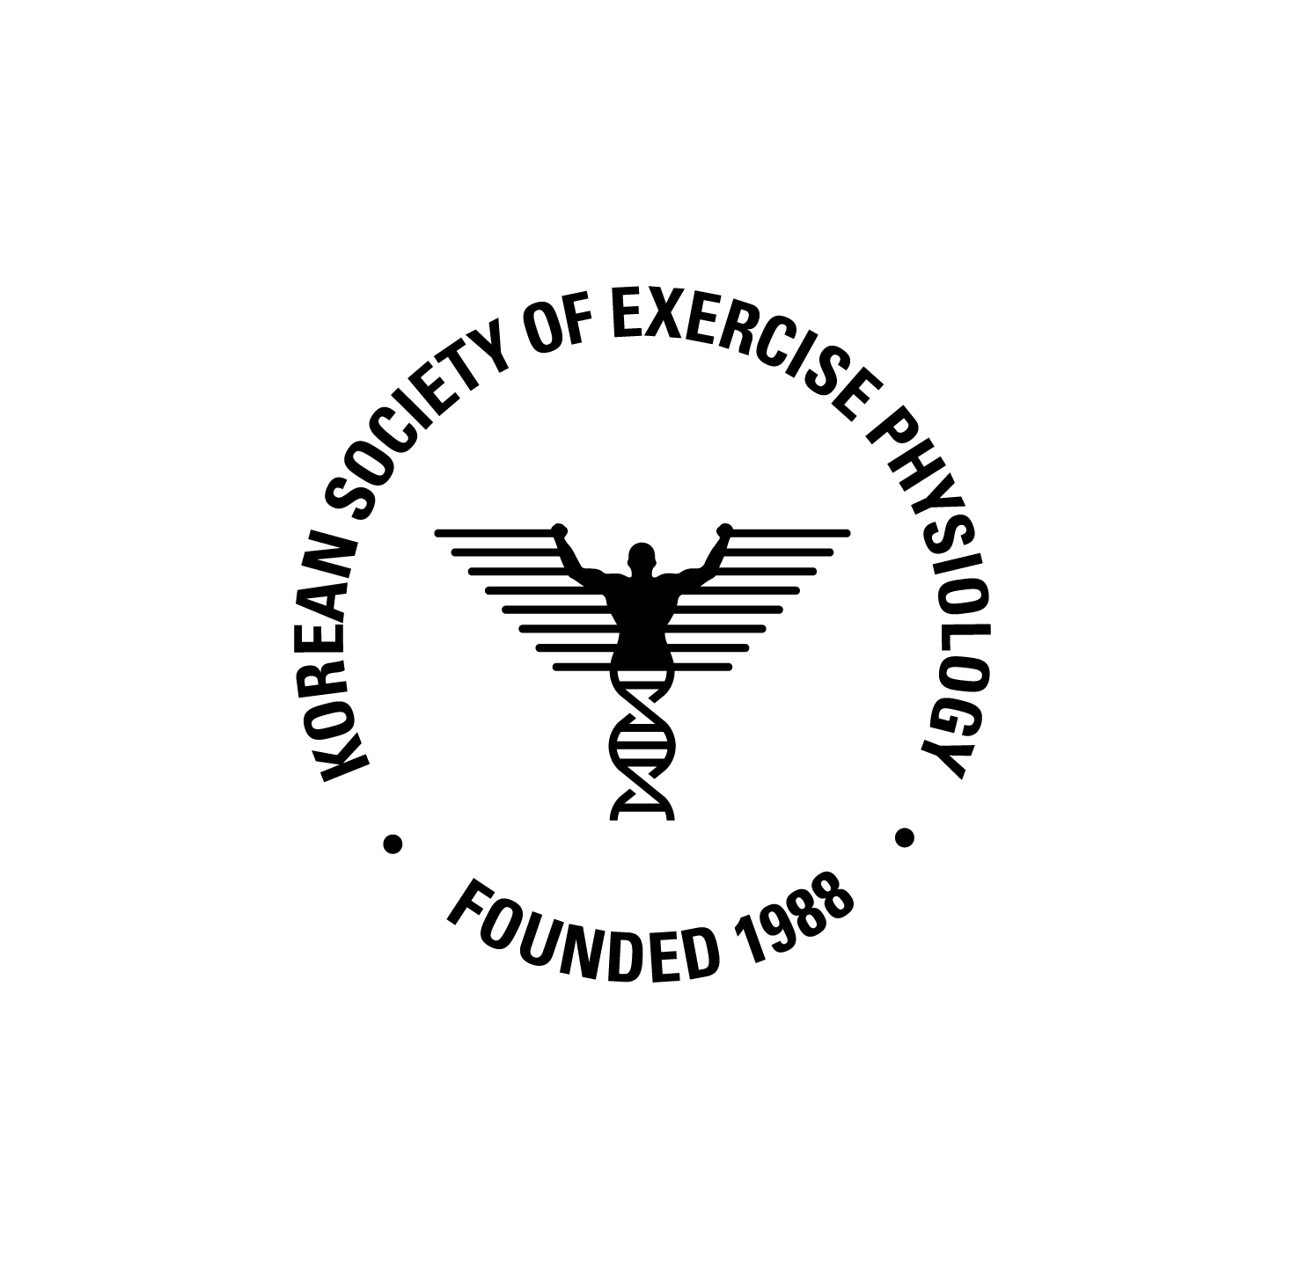Photo
Jeju National University
Laboratory of Exercise Physiology
Title _

Abstracts_ Please ensure that your abstract contains no more than 300 words. Please avoid diagrams, illustrations, tables, references, or graphics in the abstract. Provide maximum relevant information in the abstract and the following structure is obligatory: background, purpose, methods, results, conclusions.

KEYWORDS: Keywords must be 5 or less.
*Email correspondence: abcde@vwxyz.com

